**Experiment-1**

**STAR TOPOLOGY**

**Design and Configuration of Star Topologies using Packet Tracer.**

**Step 1:** 1 switch and 4 PCs

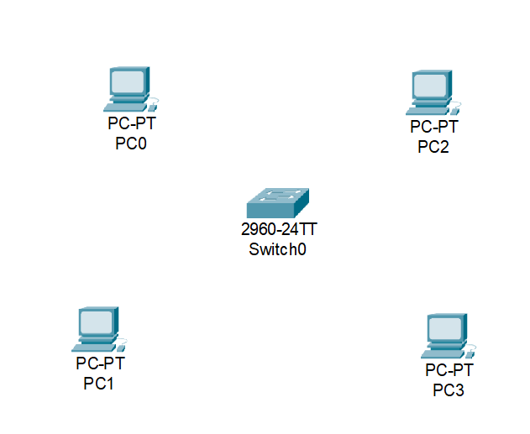

**Step2:** connect fast ethernets

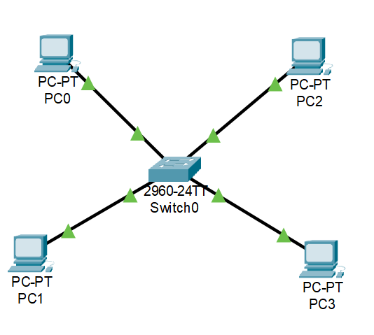

**Step3:** give Ip address for each pc

IP address for pc0:192.168.0.1

IP address for pc1: 192.168.0.2

IP address for pc2: 192.168.0.3

IP address for pc3: 192.168.0.4

**Step4:** allocate the messages

